Review questions

1. Describe the three-schema architecture.
2. Define the following terms and give an example for each term: an attribute, the domain of an attribute, a relation schema, a relation, n-tuple, degree of a relation, a relationship, a relation instance (state), a relational database schema, a relational database state, integrity constraints.
3. Why are tuples in a relation not ordered?
4. Why are duplicate tuples not allowed in a relation?
5. What is the difference between a key and a superkey?
6. Discuss the entity integrity and referential integrity constraints. Why is each considered important?

Exercises.

1. Given one possible database state for the COMPANY relational database schema as follows:

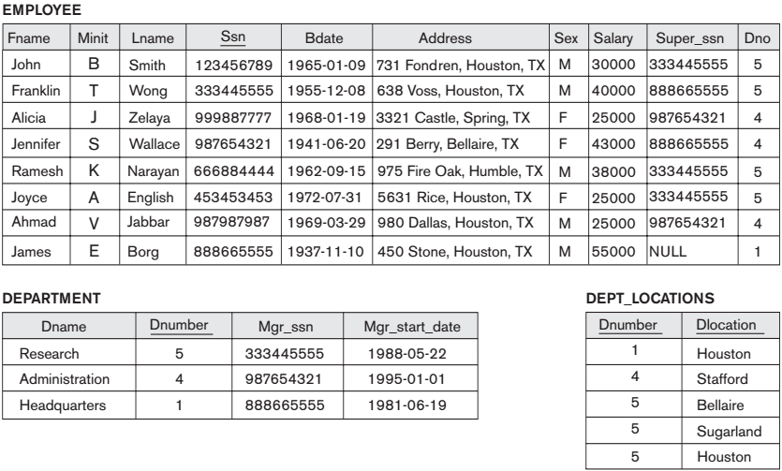

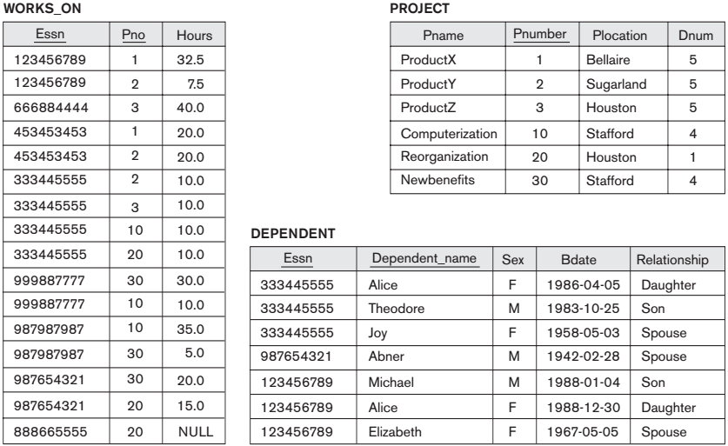

- Suppose that each of the following Update operations is applied directly to the database state shown above. Discuss all integrity constraints violated by each operation, if any, and the different ways of enforcing these constraints.

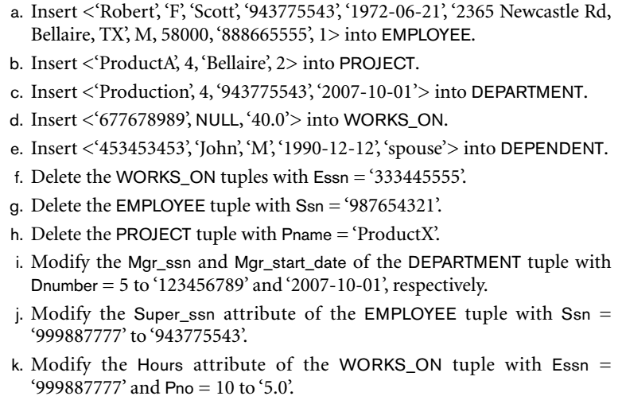

1. Given a University database as follows:

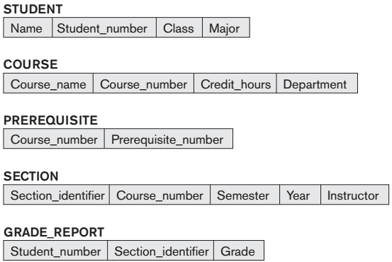

Consider the above figure. In addition to constraints relating the values of columns in one table to columns in another table, there are also constraints that impose restrictions on values in a column or a combination of columns within a table. One such constraint dictates that a column or a group of columns must be unique across all rows in the table. For example, in the STUDENT table, the Student_number column must be unique (to prevent two different students from having the same Student_number).

- Identify the column or the group of columns in the other tables that must be unique across all rows in the table.

- Identify the primary key, foreign key in each relational schema.

- Specify the following queries on the University database schema:

a. Retrieve the student_number and the name of all students in the university.

b. Retrieve the student_number and the name of all students in “Computer Science” major

c. Retrieve the prerequisite course number and course name of the course which has course number “1111’’

d. Retrieve the section identifier, course number and course name of courses which are opened in semester 1, year 2019

e. Retrieve the section identifier, course number and course name of courses which are not opened in semester 1, year 2019

f. Retrieve the section identifier, course number and course name of courses which are opened in year 2018 or 2019.

g. Retrieve the section identifier, course number and course name of courses which are opened in year 2018 and 2019.